**Name: Session:**

**Programming II**

**Lab Exercise 2/22/2022**

1. The Yukon Widget Company manufactures widgets that weigh 9.2 pounds each. Create an application that calculates how many widgets are stacked on a pallet, based on the total pallet weight. The user should be able to enter how much the pallet weighs alone (the tare weight) and how much it weight with widgets stacked on it (the gross weight). The user should click a button to display the number of widgets stacked on the pallet.

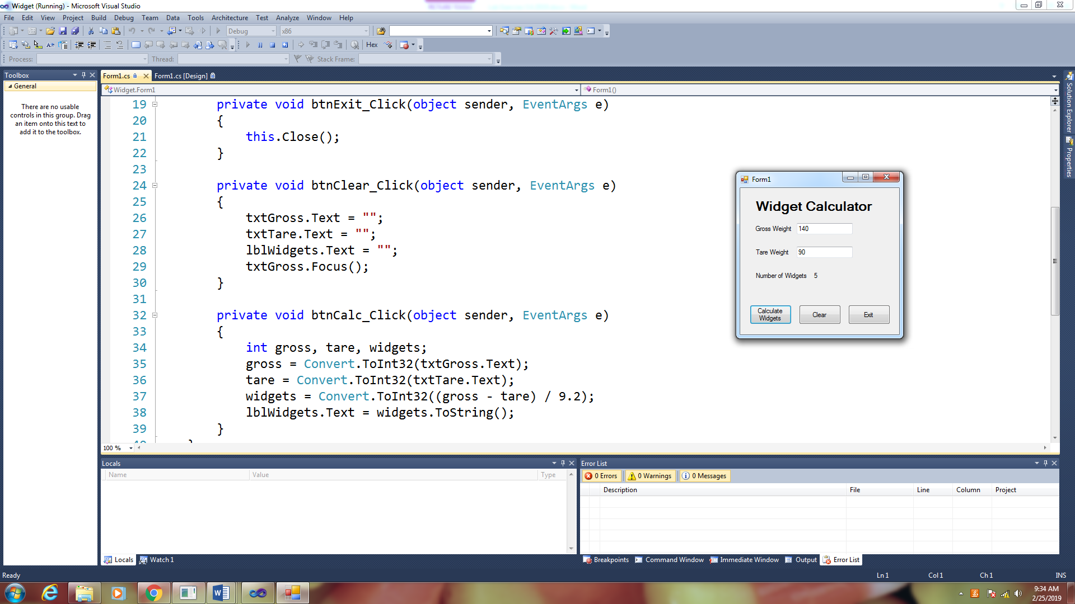

1. Create an application that converts U.S. Dollars into pounds, euros, and yen. Use the following conversion factors.

1 dollar = 0.88 Euros

1 dollar = 0.76 Pound Sterling

1 dollar = 110.81 Japanese Yen

In your code consider using named constants. For example:

const double dblYEN_FACTOR = 110.81;

const double dblEURO_FACTOR = 0.88;

const double dblPOUND_FACTOR = 0.76;

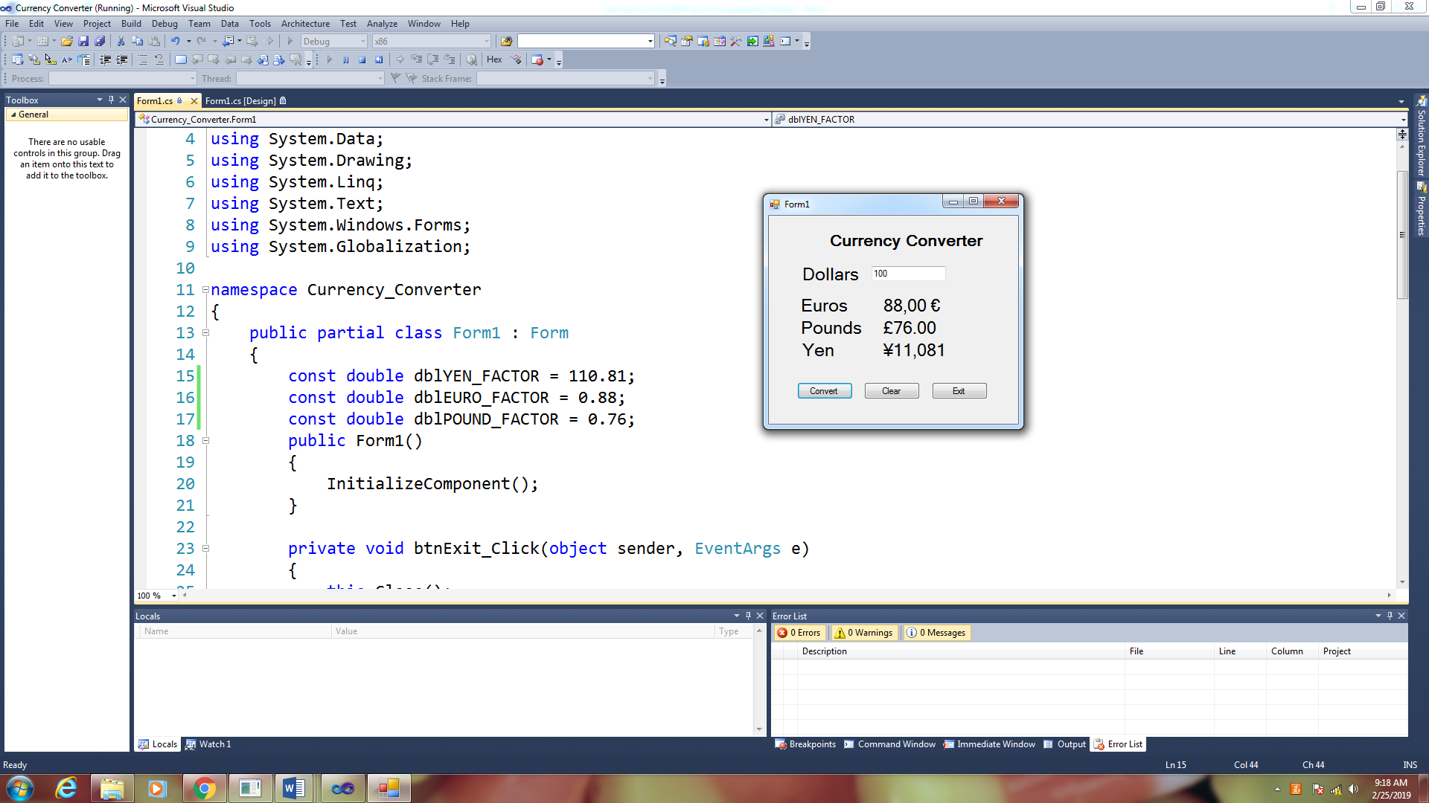

In order to use the international monetary symbols, we will need to add the Globalization Library and add a second parameter to the toString method.

Add the following Library

using System.Globalization

Modify your toString(“C”) method to the following:

lblEuros.Text = euros.ToString("c", CultureInfo.CreateSpecificCulture("de-DE"))

lblPounds.Text = pounds.ToString("c", CultureInfo.CreateSpecificCulture("en-GB"))

lblYen.Text = yen.ToString("c", CultureInfo.CreateSpecificCulture("ja-JP"))

**When you have completed these two applications, submit your source code and a screen shot of your running application.**